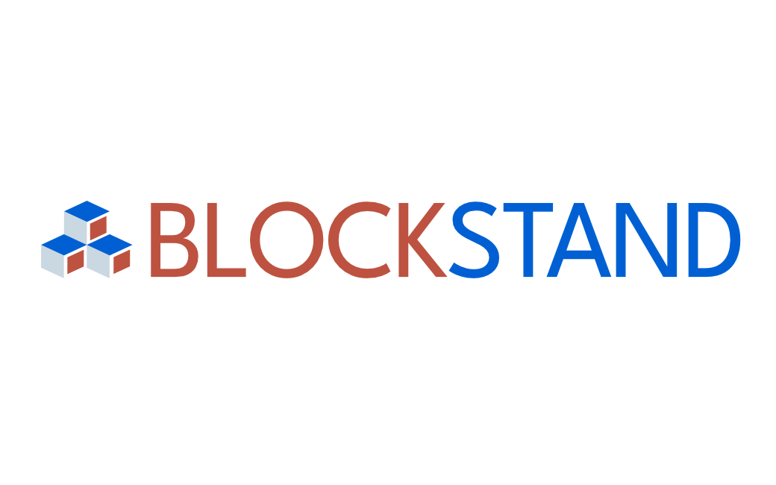
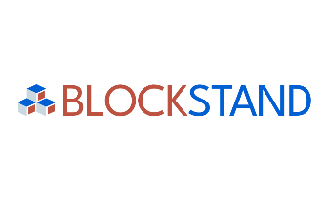

Final Report
on the activities performed by
[expert’s name]
INDEX
1 GENERAL INFORMATION 3
1.1 Expert name: 3
1.2 SDOs, TCs, WGs or other SDO internal groupings where the expert participated: 3
1.3 Standards to which the expert has contributed: 3
1.4 Description of work carried out (including the timeline) and contribution developed: 3
1.5 Supporting documents, concrete deliverables or any other proof of activity related to the contribution/s 3
2 RELEVANCE 4
2.1 Please explain how your work is relevant to the Blockchain standardisation landscape: 4
2.2 Please explain how your work is relevant to the European Blockchain Community: 4
2.3 Please explain how your contribution links to Europe’s blockchain/DLT standardisation priorities and needs: 4
3 IMPACT 4
3.1 Impact on supporting the EU's goal in achieving Digital Sovereignty: 4
3.2. Impact on the European industrial leadership and economic competitiveness: 4
3.3 Societal impact (if any): 4
3.4 Environmental (sustainability) impact (if any): 4
3.5 Any other impacts observed: 4
4 CHALLENGES 5
4.1 Have you faced any difficulties/challenges working on your contribution? If yes, please explain: 5
4.2 Have you identified any potential external risks and/or challenges working on your contribution (e.g., potential opposition to your proposals from other standardisation experts, etc?)? 5
4.3 Based on your work, could you suggest any potential recommendations to be addressed to the Blockchain community and/or to decision makers? 5
5 SUSTAINABILITY 5
5.1 What are the main lessons learned from your work on this contribution? Are there any recommendations for other experts working on the topic? 5
5.2 What follow-up actions should be taken to sustain or scale-up the impact related to your contribution? 5
6 ADDITIONAL QUESTIONS 5
6.1 Do you plan to continue the work related to your contribution in any other framework? 5
6.2 Have you implemented any dissemination activities or mentioned BlockStand in your interventions, social media, or any other channels/tools? If yes, please provide an overview with relevant information, such as links, event names, dates, etc. (where available) 5

Please fill in all the information requested below.

The purpose of the Final Report is to provide the Consortium with full information on the implementation of the activities supported by the BlockStand Project.
The required information includes (but is not limited to): detailed information on the activities developed, the work done in any relevant SDOs and WGs, impact of the work carried out and dissemination activities.
The information included in this report will be shared with the BlockStand Consortium, the Executive Management Board, the European Commission and, upon request, auditors appointed by the European Commission.

Part of the information included in this report might also be made available on the BlockStand website.

1 GENERAL INFORMATION

1.1 Expert name:

1.2 SDOs, TCs, WGs or other SDO internal groupings where the expert participated:

1.3 Standards to which the expert has contributed:

1.4 Description of work carried out (including the timeline) and contribution developed:
What has been, how the contribution was delivered, etc.

1.5 Supporting documents, concrete deliverables or any other proof of activity related to the contribution/s
Please provide here the list of documents that prove the implementation of the agreed activities and how they demonstrate the contribution. The supporting documents shall be added as an annex to this document, linked if publicly available or sent as attachments when submitting the Report.

2 RELEVANCE
If the candidate applied for one-deliverable contribution, this part can be left empty, information will be taken from the Expert Contribution Report.
For the experts who have developed 2-3 contributions, please, summarise your inputs from all Expert Contribution Reports which you have produced, and provide a concise joint summary below, including any relevant information on how the work carried out is relevant to the Blockchain community and what is its added value (e.g. does it cover any new and previously unexplored aspects? Does it contribute to the ongoing work in some critical areas?):

2.1 Please explain how your work is relevant to the Blockchain standardisation landscape:

2.2 Please explain how your work is relevant to the European Blockchain Community:

2.3 Please explain how your contribution links to Europe’s blockchain/DLT standardisation priorities and needs:
(Specifically, relating to the priorities described in the Blockchain Chapter of the Rolling Plan for ICT Standardisation 2023)

3 IMPACT
In relation to the following areas, please provide any relevant information on the overall impact of your work.

3.1 Impact on supporting the EU's goal in achieving Digital Sovereignty:

3.2. Impact on the European industrial leadership and economic competitiveness:

3.3 Societal impact (if any):
Please provide any information on how the work developed can have a positive impact on societal aspects (e.g. health, education, security, inclusiveness and easier access to technology or services for different stakeholders, etc.).

3.4 Environmental (sustainability) impact (if any):
Please provide any information on how the work developed can have a positive impact on environmental aspects (e.g. energy/water consumption, recycling and waste management etc.).

3.5 Any other impacts observed:

4 CHALLENGES

4.1 Have you faced any difficulties/challenges working on your contribution? If yes, please explain:

4.2 Have you identified any potential external risks and/or challenges working on your contribution (e.g., potential opposition to your proposals from other standardisation experts, etc?)?

4.3 Based on your work, could you suggest any potential recommendations to be addressed to the Blockchain community and/or to decision makers?

5 SUSTAINABILITY

5.1 What are the main lessons learned from your work on this contribution? Are there any recommendations for other experts working on the topic?

5.2 What follow-up actions should be taken to sustain or scale-up the impact related to your contribution?

6 ADDITIONAL QUESTIONS

6.1 Do you plan to continue the work related to your contribution in any other framework?

6.2 Have you implemented any dissemination activities or mentioned BlockStand in your interventions, social media, or any other channels/tools? If yes, please provide an overview with relevant information, such as links, event names, dates, etc. (where available)

DISCLAIMER
The European Commission support for the production of this publication does not constitute an endorsement of the contents which reflects the views only of the authors, and the Commission cannot be held responsible for any use which may be made of the information contained therein.

This document is proprietary of the BlockStand Consortium.
Project material developed in the context of Project Management & Implementation activities is not allowed to be copied or distributed in any form or by any means, without the prior written agreement of the BlockStand Consortium.
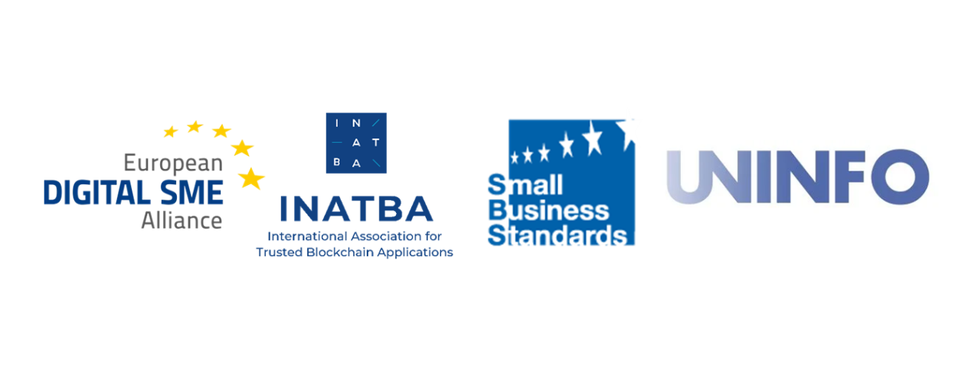

More details are available at the link https://joinup.ec.europa.eu/collection/rolling-plan-ict-standardisation/blockchain-and-distributed-digital-ledger-technologies-rp2023

