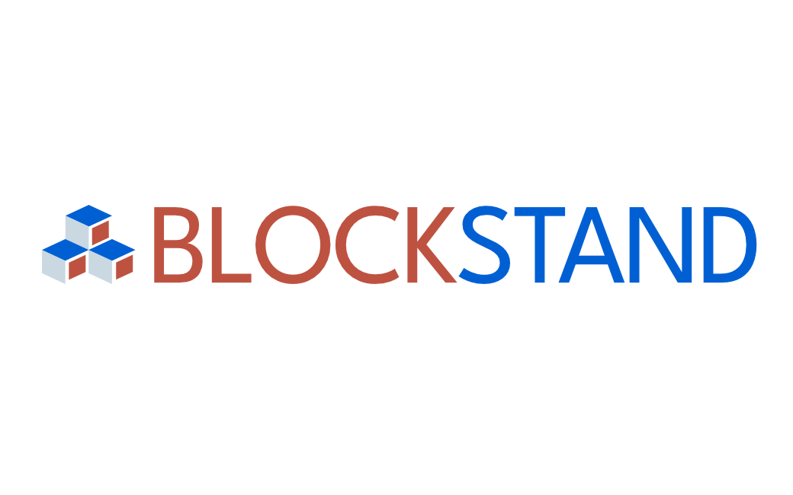
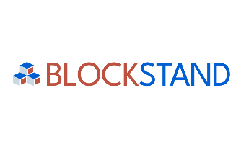

Expert Contribution Report
[expert’s name]
INDEX
1 GENERAL INFORMATION 3
1.1 Expert name: 3
1.2 SDOs, TCs, WGs or other SDO internal groupings where the expert participated: 3
1.3 Standards to which the expert has contributed: 3
1.4 Description of work carried out (including the timeline) and contribution developed: 3
1.5 Supporting documents, concrete deliverables or any other proof of activity related to the contribution/s 3
2 RELEVANCE 3
2.1 Please explain how your work is contributing to the overall Blockchain standardisation landscape: 3
2.2 Please explain how your work is relevant to / will benefit the European Blockchain Community or any specific stakeholder groups: 3
2.3 Please explain how your contribution links to Europe’s blockchain/DLT standardisation priorities and needs: 3
3 SUSTAINABILITY 4
3.1 Please explain how you are expecting to keep working on the topic in the future (after the end of the contract with BlockStand): 4
3.2 Please explain what follow ups do you plan in the future (if any): 4
3.3 Please share any recommendations and/or ideas on how this contribution might be used/reused/continued/updated/otherwise exploited by other stakeholders and/or by the BlockStand consortium: 4

Please fill in all the information requested below.

The purpose of this Report is to provide the Consortium with full information on the implementation of the activities included in the deliverable funded by the BlockStand Project.
The required information includes (but is not limited to): detailed information on the activities developed, the work done in any relevant SDOs and WGs, impact of the work carried out and dissemination activities.
The information included in this report will be shared with the BlockStand Consortium, the Executive Management Board, the European Commission and, upon request, auditors appointed by the European Commission.
Some information may be used and made publicly available by the Consortium to showcase some details on the funded projects and on success stories.

1 GENERAL INFORMATION

1.1 Expert name:

1.2 SDOs, TCs, WGs or other SDO internal groupings where the expert participated:

1.3 Standards to which the expert has contributed:

1.4 Description of work carried out (including the timeline) and contribution developed:
What has been done by the expert, how the contribution was delivered, etc.

1.5 Supporting documents, concrete deliverables or any other proof of activity related to the contribution/s
Please provide here the list of documents that prove the implementation of the agreed activities and how they demonstrate the contribution. The supporting documents shall be added as an annex to this document, linked if publicly available or sent as attachments when submitting the Report.

2 RELEVANCE

2.1 Please explain how your work is contributing to the overall Blockchain standardisation landscape:
(Does it cover any new and previously unexplored aspects? Does it contribute to the ongoing work in some critical areas?)

2.2 Please explain how your work is relevant to / will benefit the European Blockchain Community or any specific stakeholder groups:

2.3 Please explain how your contribution links to Europe’s blockchain/DLT standardisation priorities and needs:
(Specifically, relating to the priorities described in the Blockchain Chapter of the Rolling Plan for ICT Standardisation 2023)

3 SUSTAINABILITY

3.1 Please explain how you are expecting to keep working on the topic in the future (after the end of the contract with BlockStand):

3.2 Please explain what follow ups do you plan in the future (if any):

3.3 Please share any recommendations and/or ideas on how this contribution might be used/reused/continued/updated/otherwise exploited by other stakeholders and/or by the BlockStand consortium:

DISCLAIMER
The European Commission support for the production of this publication does not constitute an endorsement of the contents which reflects the views only of the authors, and the Commission cannot be held responsible for any use which may be made of the information contained therein.

This document is proprietary of the BlockStand Consortium.
Project material developed in the context of Project Management & Implementation activities is not allowed to be copied or distributed in any form or by any means, without the prior written agreement of the BlockStand Consortium.
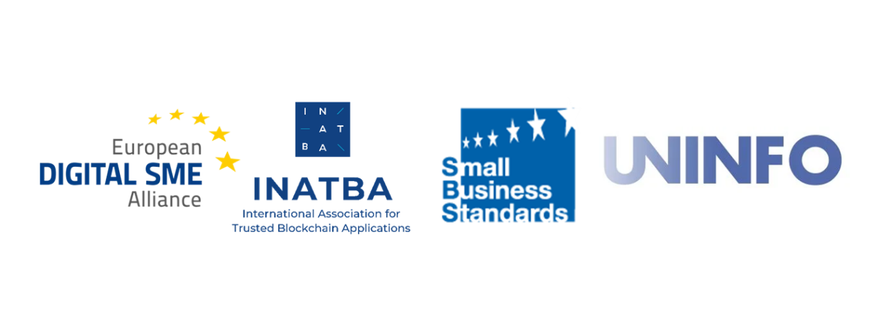

More details are available at the link https://joinup.ec.europa.eu/collection/rolling-plan-ict-standardisation/blockchain-and-distributed-digital-ledger-technologies-rp2023

