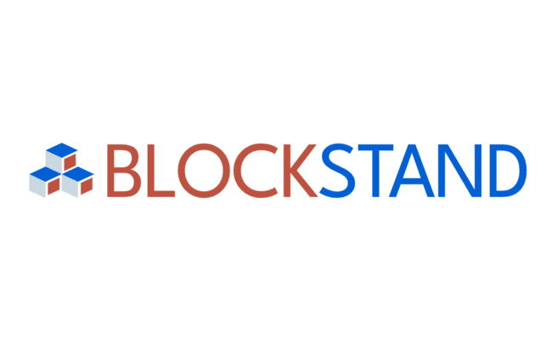
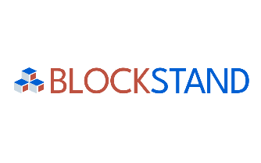

Template for Applications
Selection process for experts’ contributions in Blockchain and DLT standardisation

APPLICATION FORM TEMPLATE
The online submission form is the singular entry point for the experts to participate in the selection process by submitting their proposals for standardisation contributions. The online form is available on the website on the BlockStand website and is accessible at: https://blockstand.digitalsme.eu/form/
This template for applications may facilitate the preparation of the information requested by the form. Please be aware that only applications submitted through the online submission form will be considered and, thus, evaluated.

Applications will only be accepted from individuals and any applications for more than one person will be considered ineligible.

1 PERSONAL INFORMATION
Please note that your personal data will be treated according to the GDPR requirements, and you can consult DIGITAL SME’s Privacy Policy here.
Your personal data will not be shared with third parties, other than BlockStand consortium partners, and other similar projects for the purpose of confirming that no double-funding occurs. For more information, please consult Guidelines for Applicants.

1.1 Name*

1.2 Surname*

1.3 Email*

1.4 Are you applying as an individual, or are you affiliated to any organisation (employer)? *
Individual
I am affiliated to an organisation

If “Individual is selected:

1.4.1 Are you a national of an EU-member state?
Yes
No

If “I am affiliated to an organisation” is selected:

1.4.1 Organisation to which you are affiliated

1.4.2 Type of organisation to which you are affiliated (start-up, SME, research institution, etc) *

1.4.3 Country where the organisation, to which you are affiliated, is registered. *
If expert is applying as an individual, please provide the nationality of the expert.

1.4.4 Job role*

1.5 Your Gender Identity*

This information is required in order to ensure that sufficient measures are taken to ensure gender balance among the selected experts.

1.6 Contact phone number (please add the national prefix)*

2 PROPOSAL

2.1 Summary of the proposed activities (max 250 words) *

2.2 Intended start date for your work*

2.3 Intended end Date of your work*

2.4 For which type of contributions you are applying? *
Short-term (3 months) – 1 deliverable
Long-term (12 months) – 2 to 3 deliverables

2.4.1 How many final contributions (deliverables) do you propose to submit? *

This information is required if “long-term contribution” is selected.
2
3

2.5 Are the activities proposed in the contribution already, even partially, financed under other EU projects, Standardisation Bodies, EU programmes, etc? *
Yes
No

3 EXCELLENCE & IMPLEMENTATION

3.1 Which Standards Developing Organisations (SDO) and which Technical Committees / Working Groups (other internal groupings) will you contribute to? If your work covers more than one SDO / Group, etc., please mention them all.

3.2 Reference standards - specific to your proposed topic. *

3.3 What is your proposed standardisation contribution / contributions – in case you apply for more than one? *

Non exhaustive list: Technical Report, new proposed Work Item, proven active intervention and contributions to Technical Committee’s or other meetings, other relevant activities as indicated in the Guidelines for Applicants.

Should you propose other relevant standardisation activities (such as blog post explaining technical work on standard, SME guideline(s) for certain standards, etc.), please, specify it here.

3.4 Describe the rationale behind the proposed activity: why is it necessary and how does it address the current blockchain / DLT standardisation needs? (Maximum length: 600 words) *

3.5 Summarise your expertise in blockchain and DLT standardisation as well as your broader expertise in Standardisation (e.g., previous contributions to standards developments, participation to other WGs, TCs, Focus Groups, publications, or papers) (Maximum length: 600 words) *

3.6 Do you play any leading role(s) in standardisation (such as convenor or Chair of Technical Committee, etc.)? If yes, please provide some details.

4. IMPACT

4.1 Does your proposed activity link to the EU blockchain / DLT standardisation priorities, as identified in the Rolling Plan for ICT Standardisation 2023 (Blockchain chapter)? If yes, please explain how.

4.2 Describe the expected impact of the proposed activity and how it will support the representation of European interests in more general terms (maximum length: 600 words) *

4.3 Does your proposed activity contribute to addressing environmental sustainability aspects? If yes, what will be the impacts in support of circularity, green and digital transition and greening of the EU economy overall? (Maximum length: 250 words) *

5 WORKPLAN & TIMELINE

5.1 Please describe the activities’ workplan with feasible timeline (your preparatory work, if any, dates of meeting(s) you plan to attend, date when your main contribution would be delivered, etc). (Maximum length: 600 words) *

5.2 Please explain which supporting documents, concrete deliverables or proofs of your contribution will be provided. *

For example: minutes of the Technical Committee meeting, demonstrating your intervention / presentation, agenda points, etc.

6 ADDITIONAL REQUIREMENTS

☐ CV* - PDF submission

☐ Declaration of Honor* - PDF submission

☐ Picture – (optional: it would be used to publish your success story on the BlockStand website, social media, and other communications – you will be informed in advance about the planned usage of your photo).

☐ I consent to display name, proposed activities, and picture (if provided) on BlockStand’s website for dissemination purposes. *

☐ I consent to DIGITAL SME’s privacy policy and to my information being processed for the purposes related to BlockStand Project. *

☐ I am aware that, if selected, I will be required to contribute to BlockStand’s Technical Coordination Board (upon my availability, attending to meetings and/or providing online contributions and participating to the discussions). *

☐ I consent to BlockStand Consortium’s right to share the information related to the proposed activities with external projects or entities financing standardisation activities to preclude the eventuality of double funding. *

DISCLAIMER
The European Commission support for the production of this publication does not constitute an endorsement of the contents which reflects the views only of the authors, and the Commission cannot be held responsible for any use which may be made of the information contained therein.

This document is proprietary of the BlockStand Consortium.
Project material developed in the context of Project Management & Implementation activities is not allowed to be copied or distributed in any form or by any means, without the prior written agreement of the BlockStand Consortium.
